Year 6 English Transition Activity 2020
Creative writing is very important and is part of your studies in English at secondary school. Prior to your arrival at Helsby High School, we would like you to have a go at the task below and bring your completed work with you in September 2020.

The activity:
Look at the image below. What words could you come up with to describe the image? What interesting vocabulary could you use?

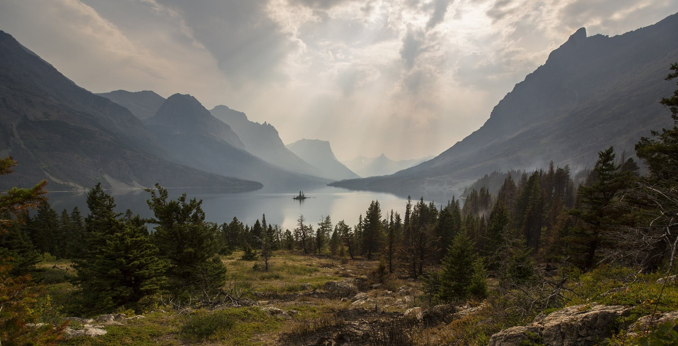

Why not use the internet, or a dictionary to help you build your vocabulary? You could present your ideas in a mind map, in bullet points or any other creative way you can think of.
Words to describe the weather in the image:

Words to describe the places in the image. The forest, the mountains, the lake:

How might your senses respond? What can you see, hear, smell, touch or taste?

What events might happen on this place? Relaxing? Playing? Swimming in the lake? Investigating a strange story? What words could describe these events?

On a separate piece of paper, write a short story based on the planning you have completed above. Think about the language you use to make the story as interesting as possible. Suggested starter: If you listen, you can hear the trees whispering to each other as you tread through the darkened forest heading for the edges of the perfectly peaceful lake. But this is no holiday, let me tell you…
Please bring this planning sheet and any paragraphs you have written for your story with you in September 2020, or hand into your Year 6 teacher. We look forward to meeting you.

