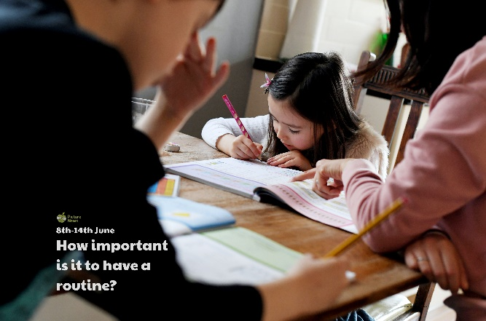

Design and make your own diary or calendar. This could be for a week or a month or longer!

Being able to tell the time is very useful when following a routine. Practise telling the time on an analogue clock. If you feel confident with this perhaps you could look at digital time and record it on an analogue clock or record digital times in 12- and 24-hour clock.

Create a list of some of the things you do in a typical day. For each of these, draw a picture then cut it out. Use them to help organise part or all of your day.

Look at the statement ‘Having a routine is better than not having one’. Split a piece of paper in half and list reasons for and against this statement. What do you think? Find out what someone in your family or in your class thinks. Use your points to write a discussion text. Include a question e.g. ‘Is having a routine better?’, an introduction, reasons for having a routine, reasons against having a routine, conclusion.

As well as using the word routine to describe a sequence of actions we follow in our day, we can also use it to describe a set sequence in a dance. Create your own dance routine!

Create a timetable for a typical weekday before lockdown and a typical weekday during lockdown. Compare the two timetables. Which timetable do you prefer? Does one have more routine than the other?

**Learning from Home**

Use the ideas below, alongside this week’s resource, to support your home learning.